**HFS Admin User Manual**

# **Introduction:**

Welcome to the **Admin Web App**! This powerful platform is designed to give administrators full control over the operations of the sales and customer management processes. As an admin, you can oversee and manage various aspects of the business, including sales managers, customers, sales agents, quotations, and performance analytics. This web app allows you to track key metrics, monitor customer journeys, assign tasks, and analyze sales trends to make data-driven decisions. With the ability to access and manage crucial information, you can ensure seamless operations and efficient management of sales activities across the organization.

# **View and Edit Your Profile:**

As you login to the admin portal you are immediately directed to your profile dashboard as shown in fig 1. This section displays your personal and account related information.

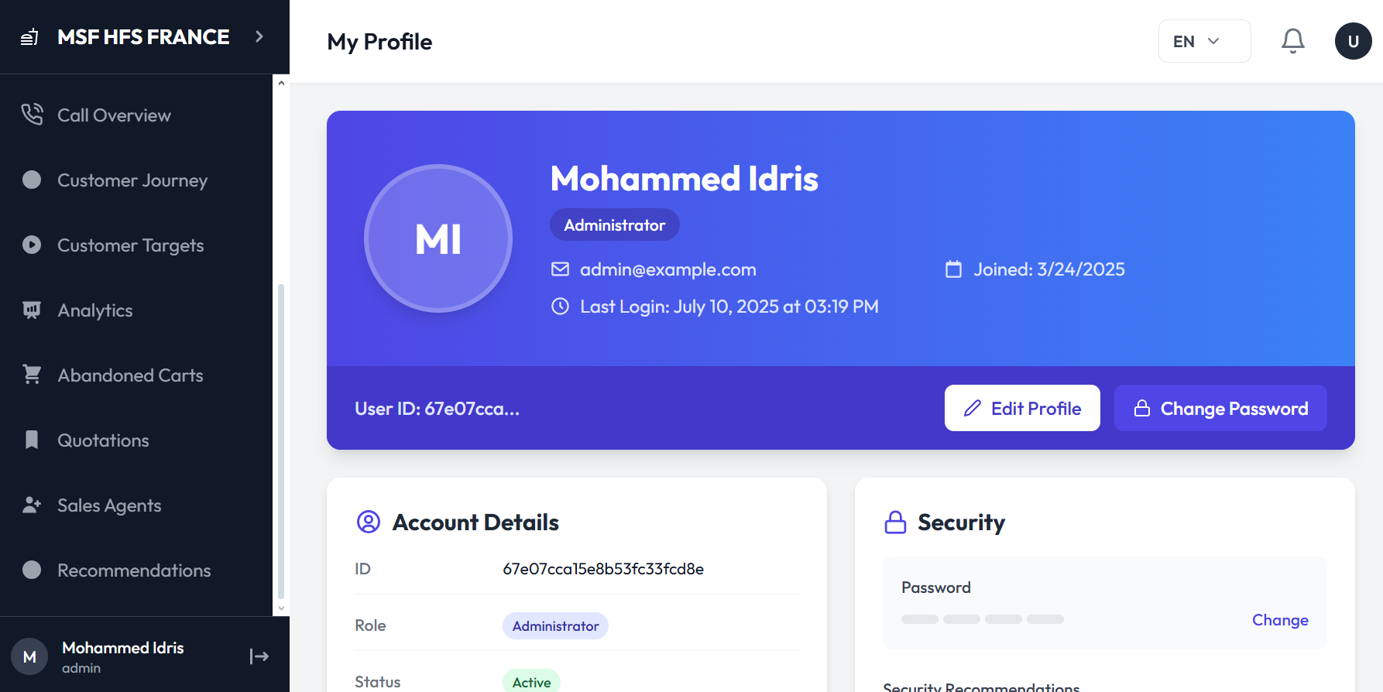

Fig 1. My profile dashboard

## **View Profile:**

You will see the following details on the **account details** section of your **profile** as shown in Fig 2**:**

* Name
* Role
* Email
* Phone Number
* Joining date
* Last login
* User ID

This information helps you verify and manage your account details

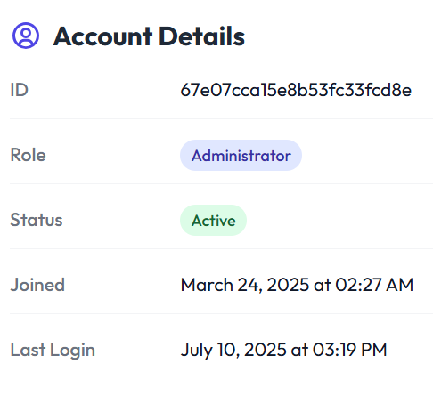

Fig 2. Admin account details on the profile

## **Edit Profile:**

You can also update your profile details by clicking on the **edit profile** button as shown in Fig 3.

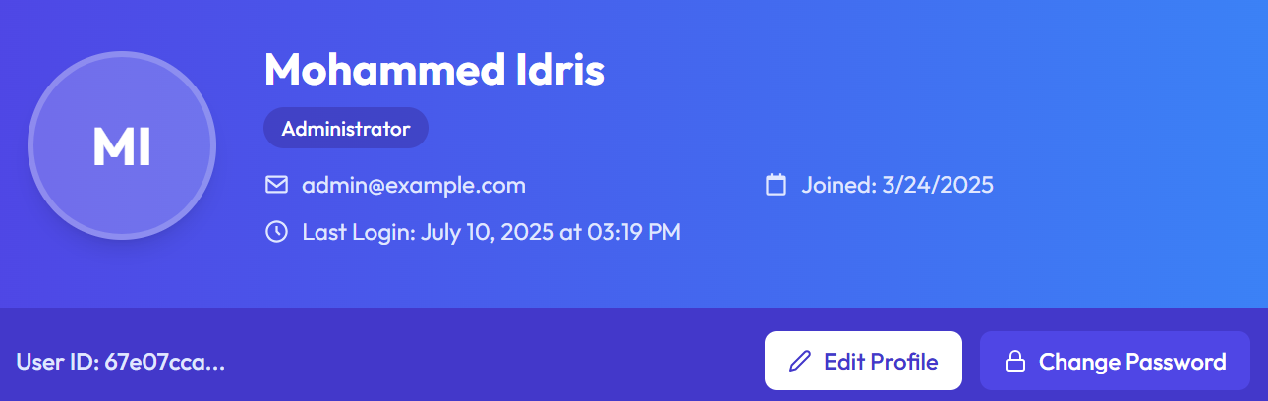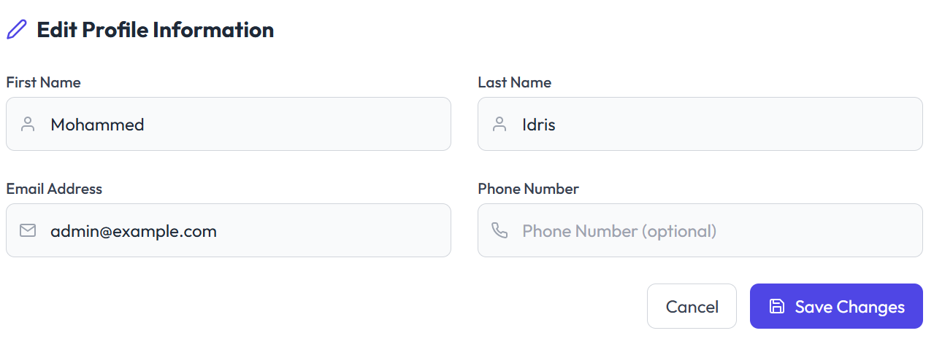

Fig 3. Editing the profile of admin

You can edit the following things on your profile:

* Name
* Phone number
* Email

## **Changing Your Password:**

To change your password you click on the **change password** button on your profile as shown in Fig 3 and follow the following steps:

* Enter current password
* Enter and confirm new password
* Click the **update password** button
* You can also click cancel if you do not want to change the password

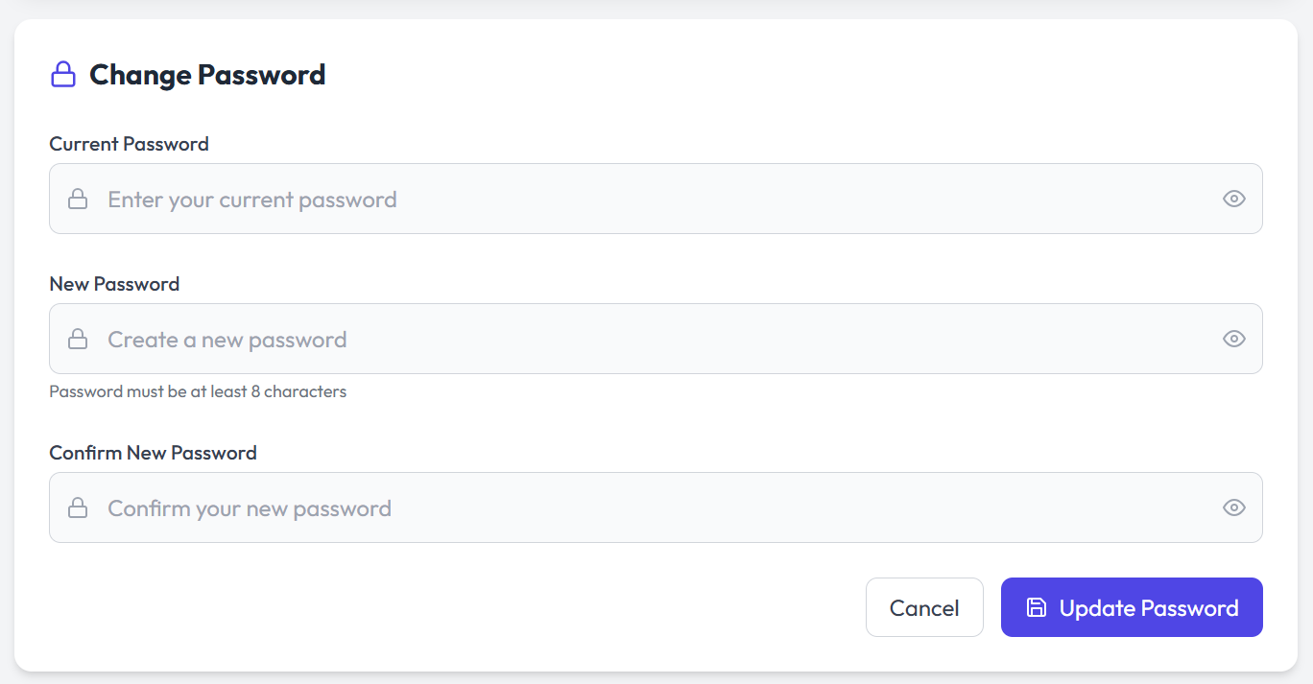

Fig 4. Changing password on sales admin profile

As you scroll to the bottom of the profile page you see a **logout** button on the bottom right. You can log out by clicking that.

# View and Manage Sales Managers:

You can manage and view the sales managers by clicking on the sales **managers** button on the left panel. Then you will land on the sales agents page where you can view and manage all the sales managers as shown in Fig 5.

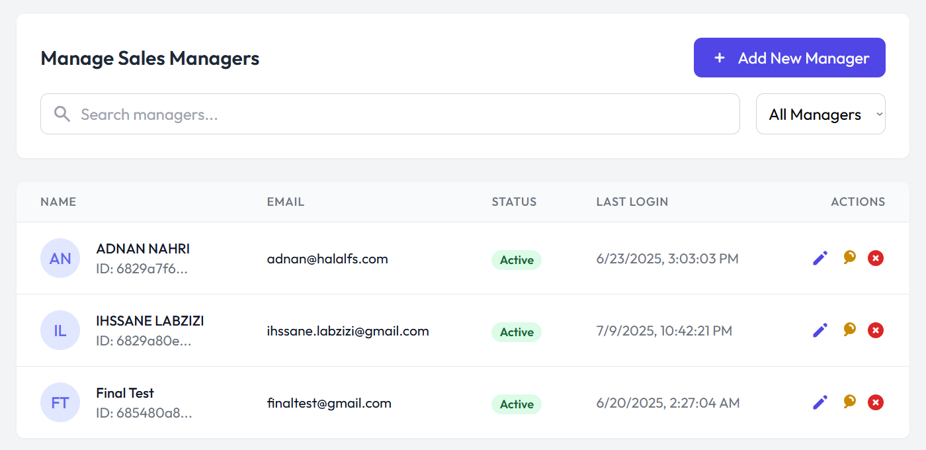

Fig 5. Sales managers dashboard

By clicking on the **add new manager** button on the top right of the screen a form will open where you have to fill information like:

* First name
* Last name
* Email address
* Password
* Confirm password

Click on the **create manager** button to create a new manager or click on cancel to exit the screen. For reference see Fig 6.

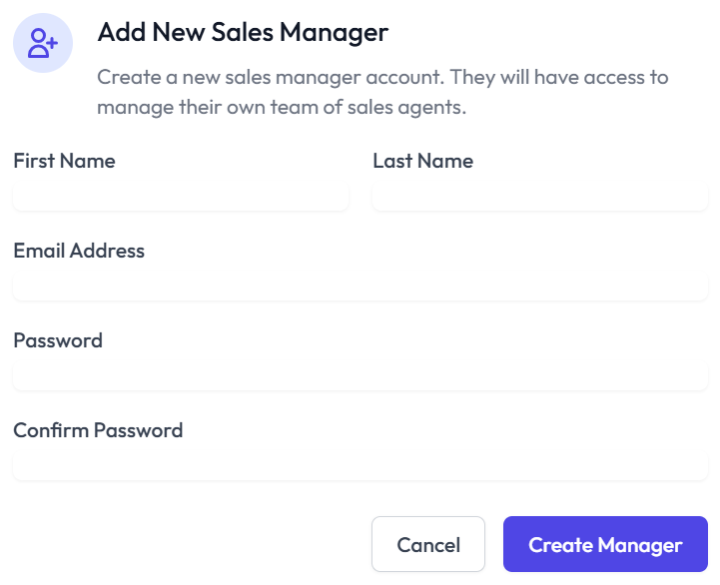

Fig 6. The form to add new sales manager

Going over to the actions column as shown in Fig 5. You can perform multiple actions for the profile of a sales agent. The actions include:

* Edit profile
* Reset password
* Deactivate profile

# Access and manage your customers:

You can shift to the customers page by clicking on the **customers** button on the left panel on the screen. Once you switch the screen you land on the **customers** screen as shown in Fig 6. Here you can view some basic analytics as well as the details of the customers. Some basic analytics that can be viewed are:

* Total customers
* Active customers
* Inactive customers
* Unassigned
* Added (in the past 30 days)

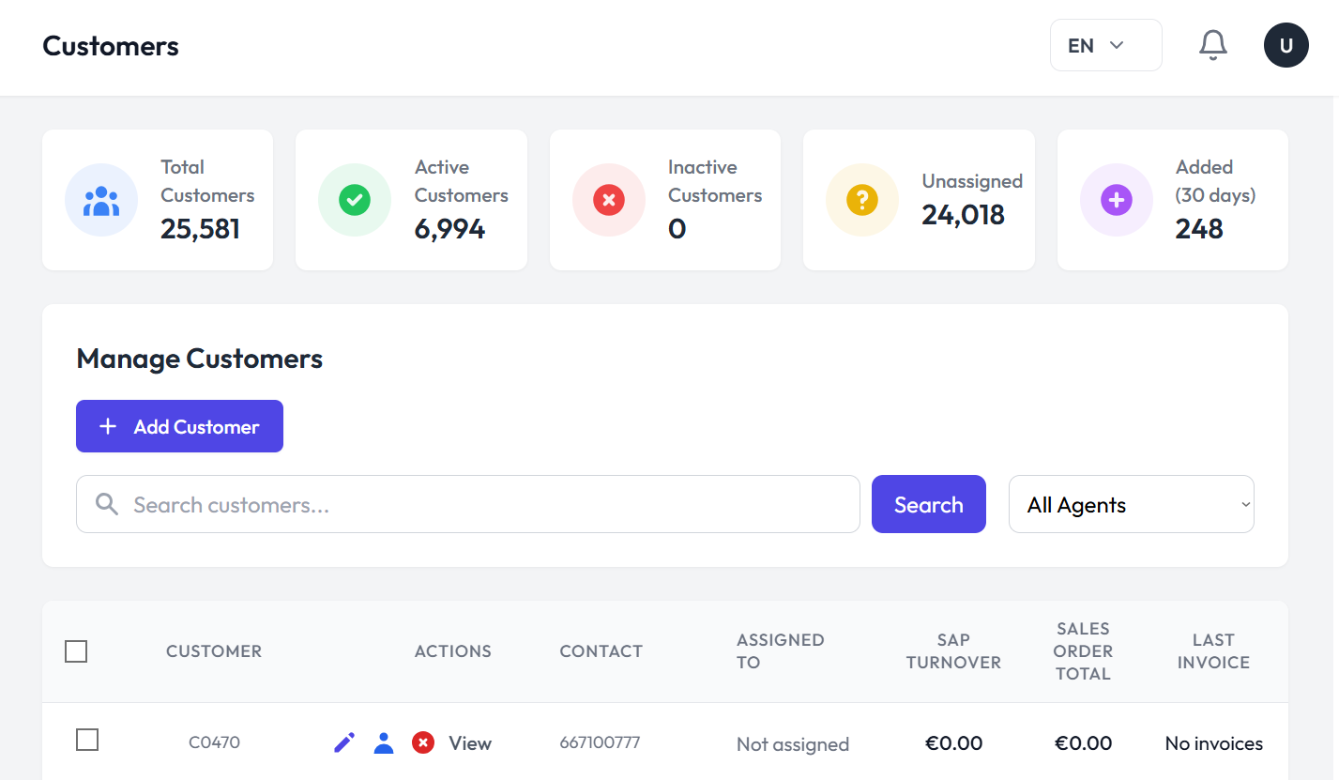

Fig 6. Customer dashboard

## Add a New Customer:

You can add a new customer to your dashboard by clicking on the **add customer** button on the customer management dashboard as shown in Fig 6. To add a new customer:

* Click the add customer button
* Fill out the basic information form shown in Fig 10

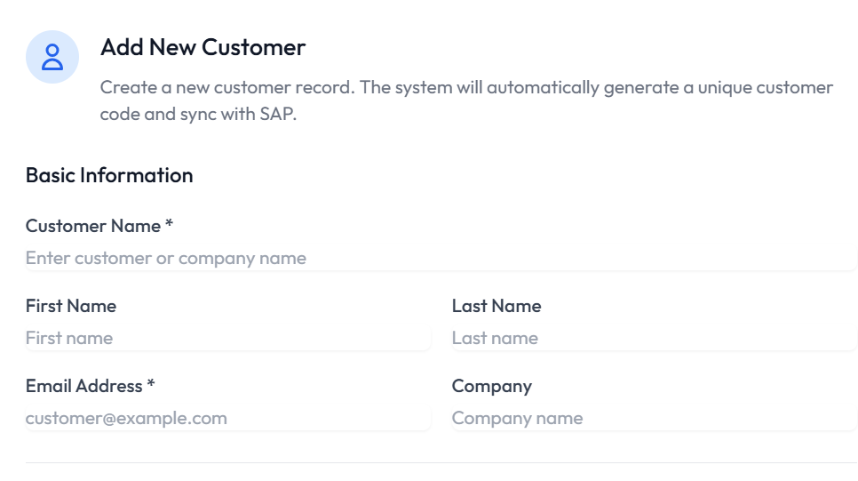

Fig 7. Basic information form on add new customer page

* Fill out the contact information form shown in Fig 8.

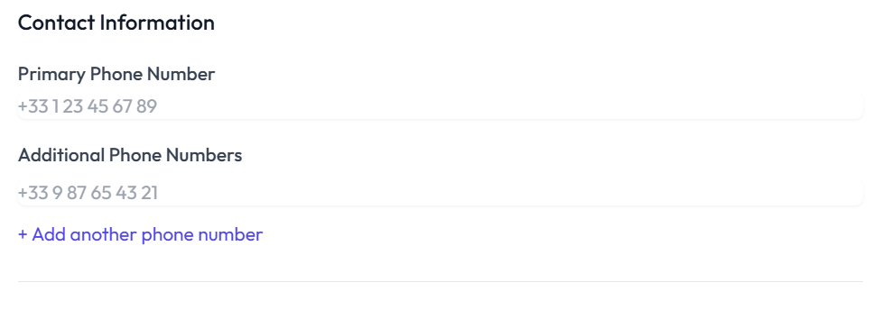

Fig 8. Contact information form on add new customer page

* Mark the status and assign sales agent as shown in Fig 9
* Add additional notes if you want to
* Click **create customer** button as shown in Fig 9

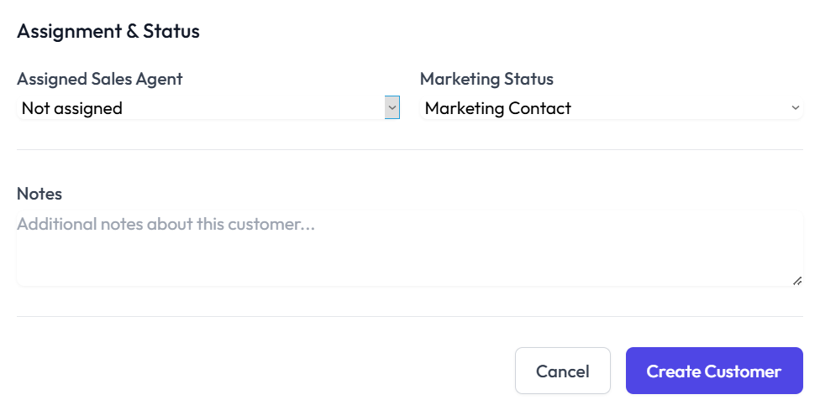  
   
Fig 9. Assignment and Statues, Notes and Create Customer button on the create new customer page

## Search a Customer:

You can search for a customer by writing their name in the search box at the top of the customers screen and pressing the **search** button as shown in Fig 6.

## Viewing Customer Details:

You can view the customer screen as shown in Fig 6. You can view the following details:

* Customer/Company name
* Actions
* Contact
* Assigned to
* SAP turnover
* Sales order total
* Last invoice
* Invoices
* Orders
* Quotations
* Abandoned carts
* Status

## Managing Customer Information:

You can manage customer information by going over to the **actions** column on the customer dashboard and clicking on the **edit** button as shown in Fig 6. You can edit the following details:

* Customer name
* Customer code
* Email address
* Phone Number

Click on the **Update Customer** button to update the information and **cancel** button to cancel the changes. You can see in Fig 13 the detailed form of customer update.

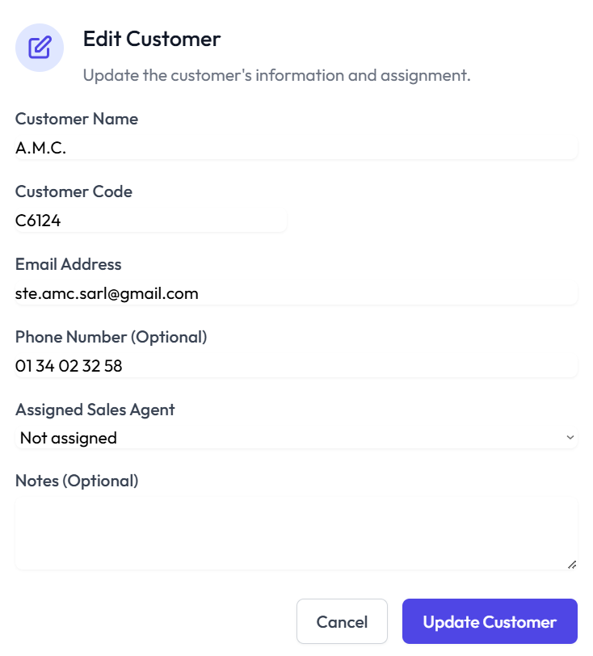

Fig 10. Edit customer form

## 

## View Customer Journey:

You can view customer journeys of a specific customer by clicking on the **view** button on the actions column on the customer dashboard as shown in Fig 6. You can view a detailed report of each customer by clicking on their view button as shown in Fig 11 and Fig 12.

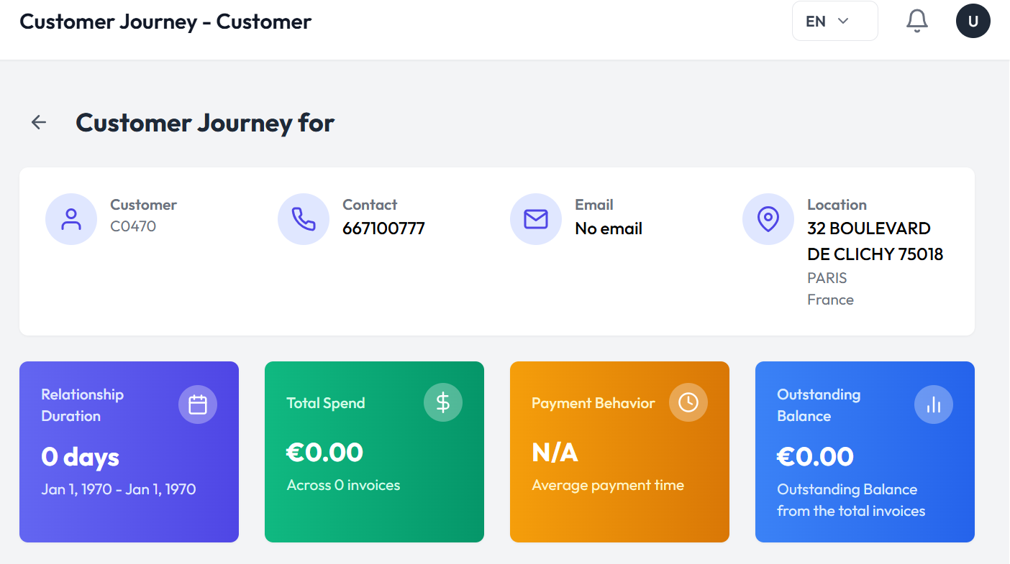

Fig 12. Customer Journey Dashboard

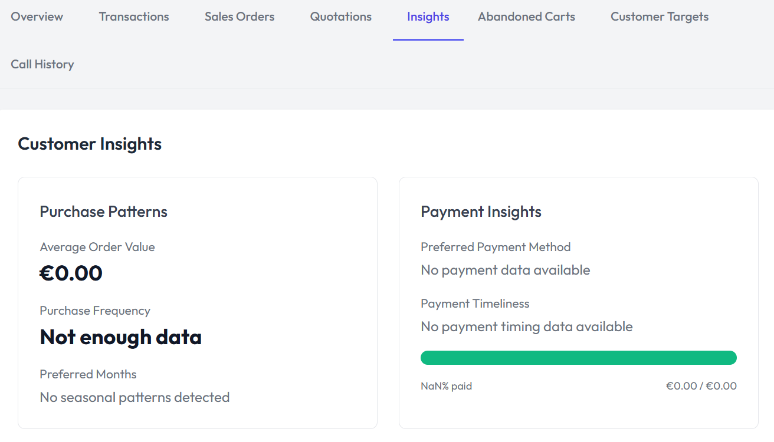

Fig 13. Customer Journey Dashboard

# Customer Invoices Dashboard:

The **Customer Invoices** section provides a comprehensive overview of your organization’s financial interactions with customers, giving you valuable insights into revenue, outstanding balances, and payment trends. Here you can view the following:

* Total revenue
* Total invoices
* Outstanding balance
* Monthly trends
* Top customers

You can see Fig 14, 15, 16 for reference.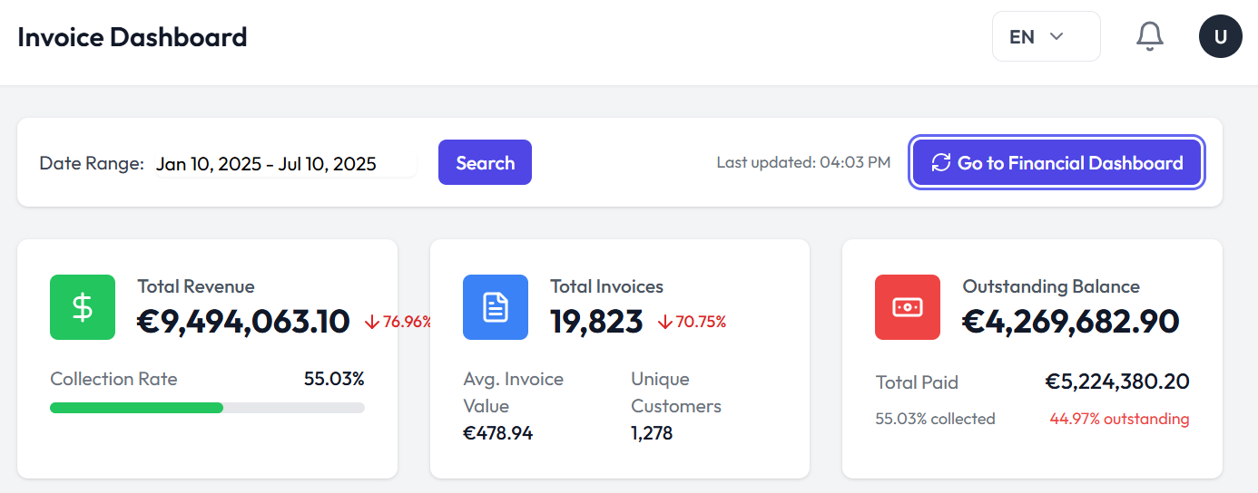

Fig 14. Overview of invoice dashboard

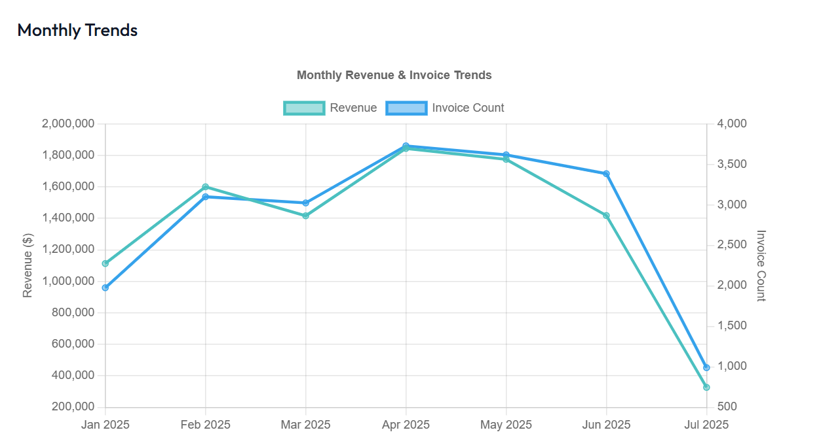

Fig 15. Monthly trends based on revenue and invoices

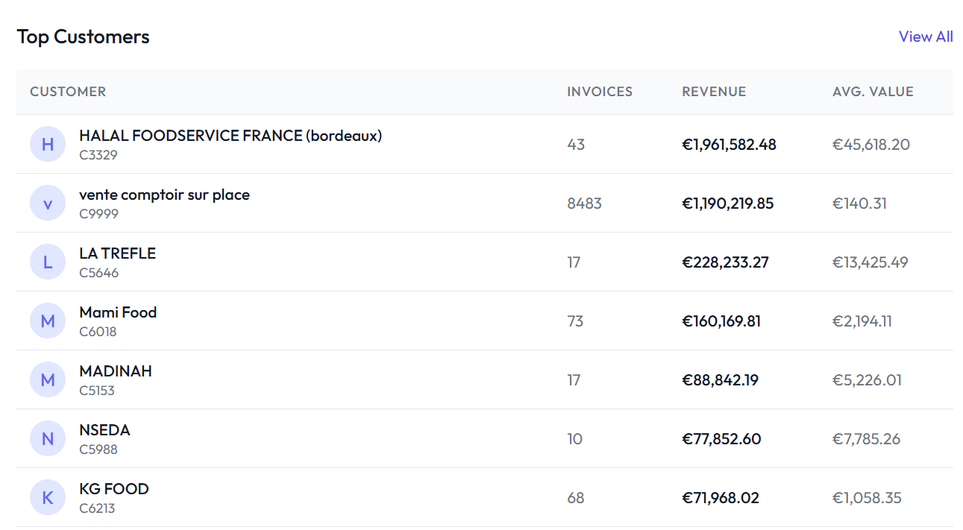

Fig 16. Top customers listed on the invoice dashboard

You can click on the **go to financial dashboard** button on the top right of the screen as shown in Fig 14 to go to the financial dashboard where you can login with your credentials.

# Create and Manage Tasks:

The tasks section helps you stay organized and focused on the daily sales activities. It allows you to create, track, and manage tasks. You can view the Pending, Awaiting approval and completed tasks here. Moreover you can also approve or reject a task.

## 

Fig 17. Task Board

## Creating a New Task:

You can create a new task by clicking on the **new task** button on the Tasks screen as shown in Fig 17. Fill out the information in the form as shown in Fig 18. The information to be filled is:

* Title
* Description
* Assign to
* Priority
* Type
* Due Date

Click on the **create task** button to create a new task and **cancel** button to exit the screen as shown in Fig 18.

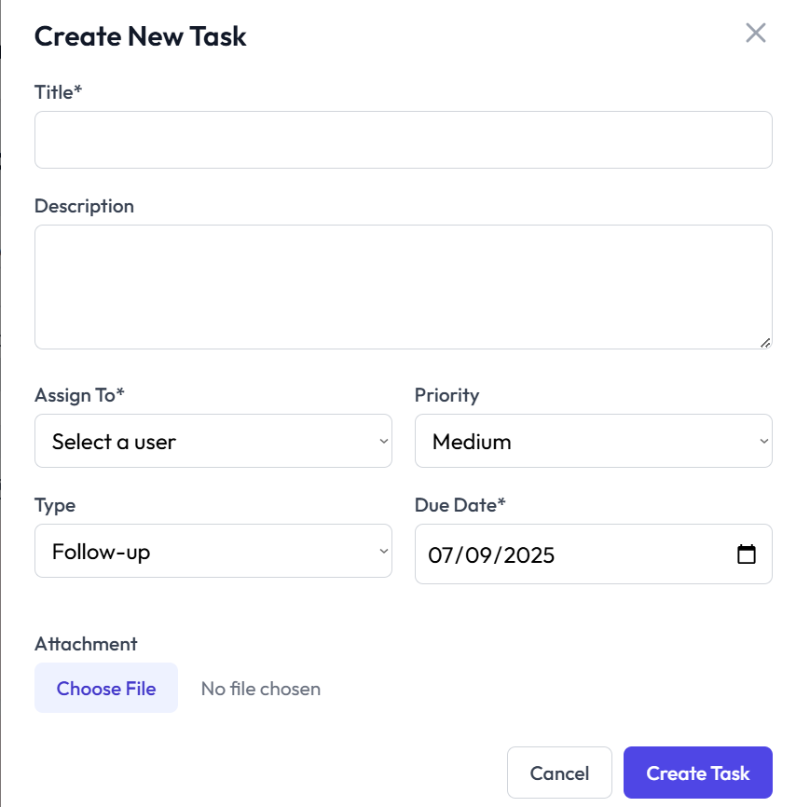

Fig 18. Create new task form

## Create New Lead:

You can also create a new lead by clicking on the **new lead** button on the task screen as shown in Fig 17. Fill out the information in the form, as shown in Fig 19 , such as:

* Full name
* Email
* Phone number
* Company
* Status
* Tags
* Notes

Click on the create lead button to create a new lead or cancel button to exit the form.

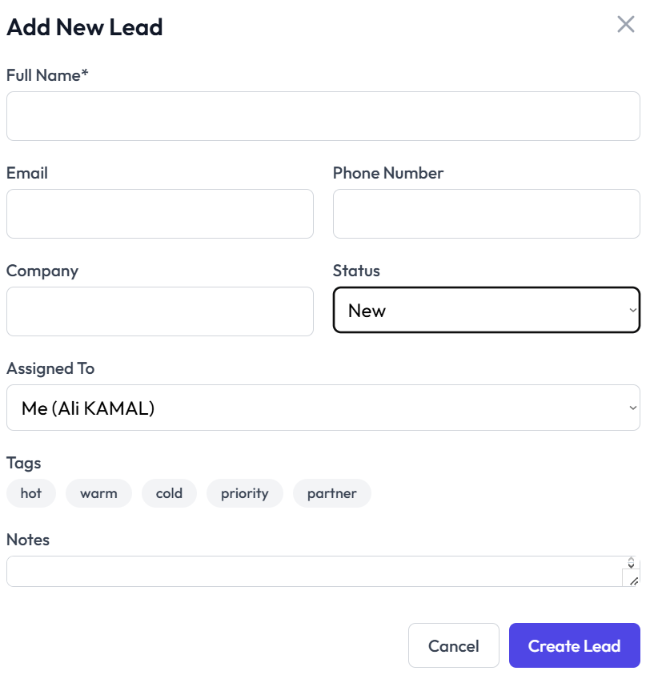

Fig 19. Add new lead form

# Call Analytics and Overview:

You can view the call analytics and overview by moving to the call overview tab. Here you can see multiple things that can be viewed in Fig 20.

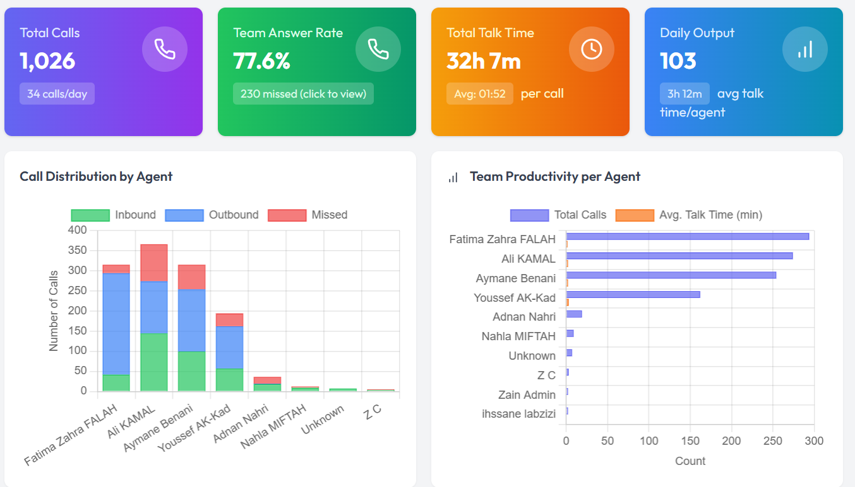

Fig 20. Call analytics of the team overall

You can also view individual **agent performance** where you can see a detailed overview and call analysis of each agent individually. By clicking on the **view details** button in the action column of a specific agent you can see the following statistics of that agent:

* Call summary
* Daily breakdown
* Hourly output
* Call log

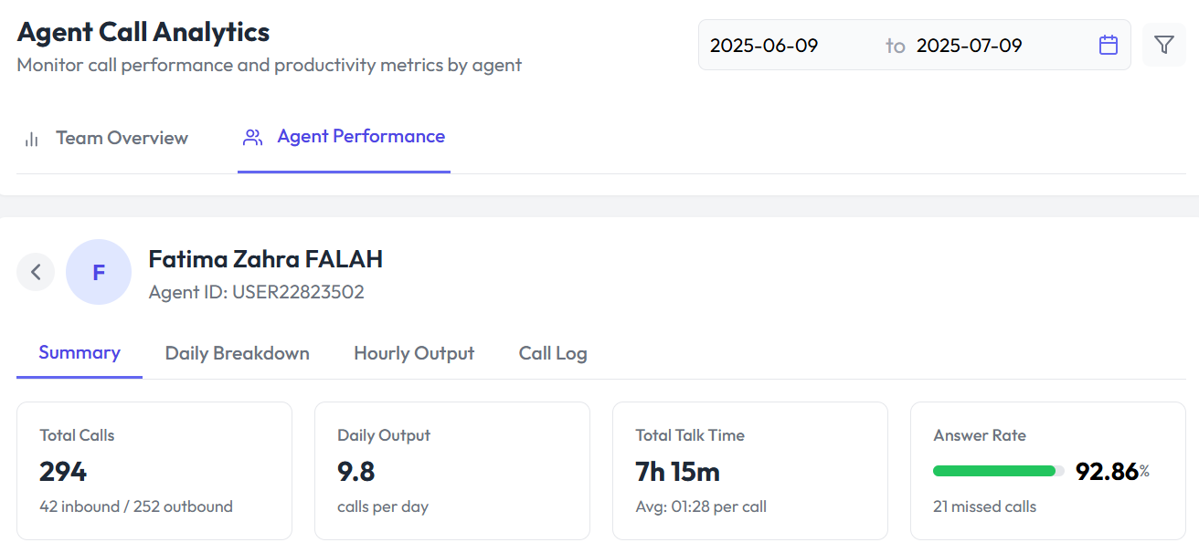

Fig 21. Call analytics of an agent individually

# Customer Journey Analytics:

The Customer Journey Analytics section provides valuable insights into the journey your customers take, from initial contact to final purchase. By tracking each step of the customer journey, this feature helps you understand customer behavior and optimize your sales process. Here you can view:

* The total number of customers
* Total revenue
* Avg. relationship with customer in the form of days
* Outstanding balance

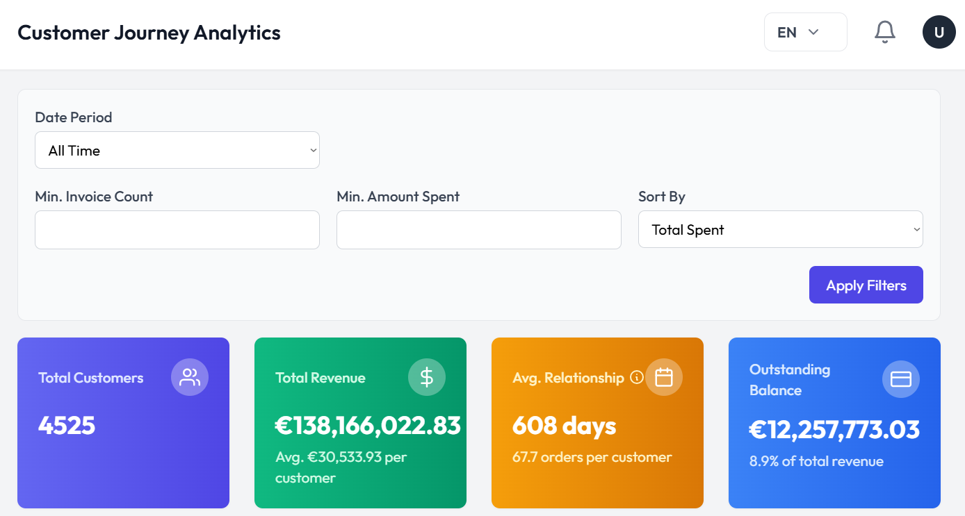

Fig 22. An overview of the customer journey analytics

You can also view these analytics in the form of charts and graphs.

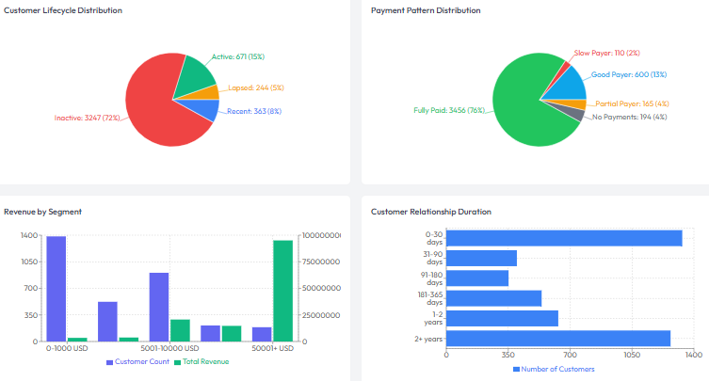

Fig 23. Graphical representation of customer analytics

You can also see the customer journey summary here where you can see:

* Customer name
* Invoices
* Total spent
* Outstanding
* Customer activity status
* Last interaction
* Patterns

For reference you can see Fig 24.

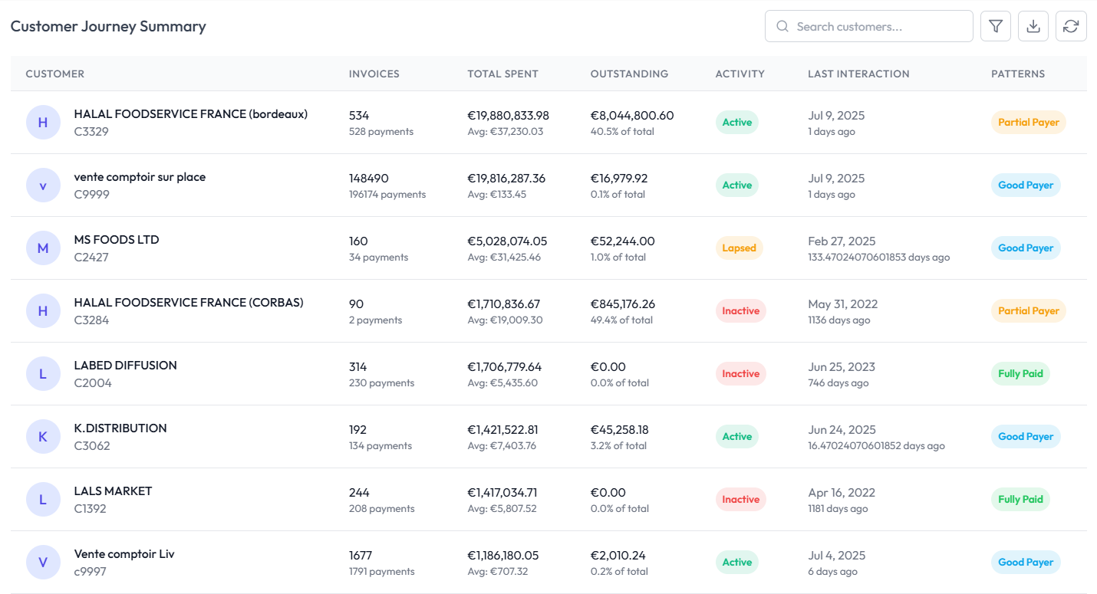

Fig 24. Customer journey overview dashboard

# Customer Targets Dashboard:

Here you can view and create customer targets and assign a sales agent to each target. Here you can see:

* Customer name
* Sales agent
* Client average
* Target amount
* Achievement
* Due date to achieve the target
* Status
* Actions (edit)

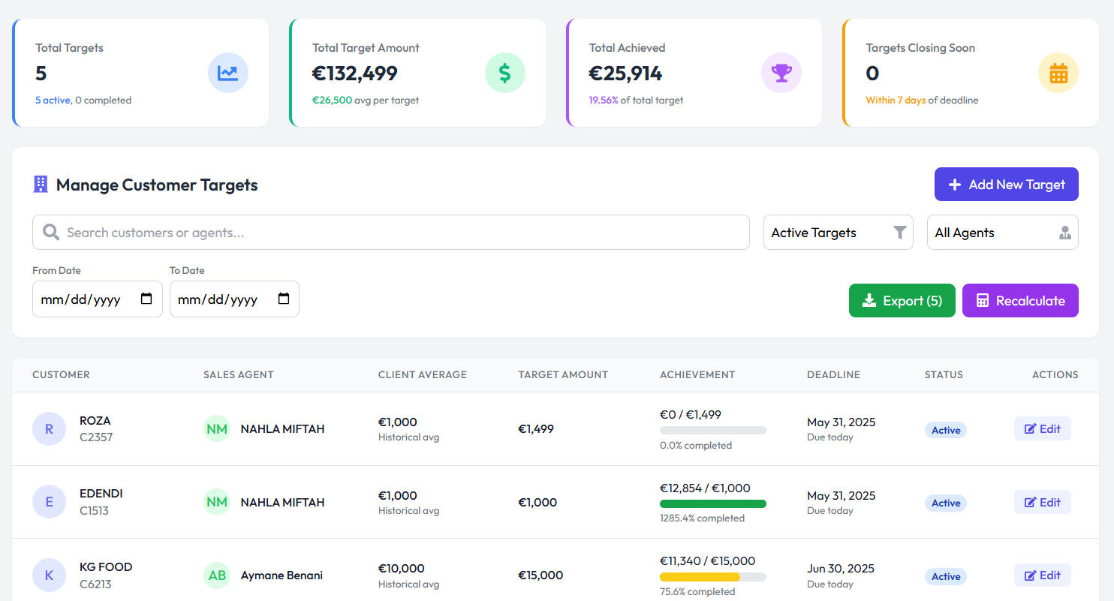

Fig 25. Customer target dashboard

You can click on the **add new target** button on the top right of the screen as shown in fig 25. A form will appear on your screen and you can fill that form to add a new target.

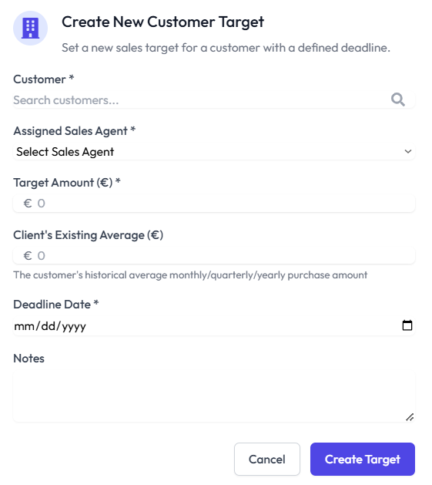

Fig 26. Create new customer target form

Click on the **create target** button to create the target or **cancel** to exit the screen as shown in fig 26.

# View Team Analytics:

You can view team analytics by going over to the team analytics dashboard where you can see the team performance separated by:

* Overview
* Agents
* Targets

The purpose of this is to know the top performers, achievements, total number of people and team target.

You can see all the mentioned things in fig 27, 28 and 29.

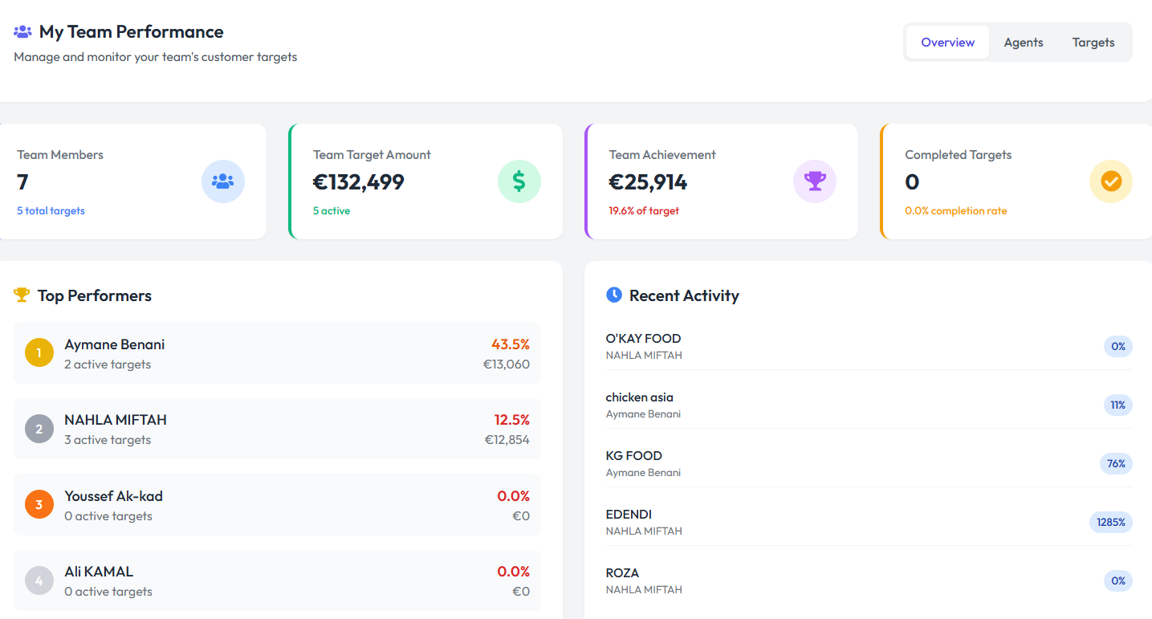

Fig 27. Team performance overview

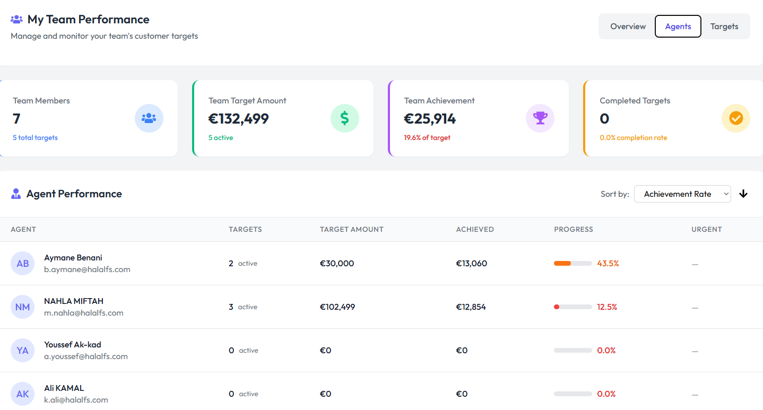

Fig 28. Team performance contribution of each agent

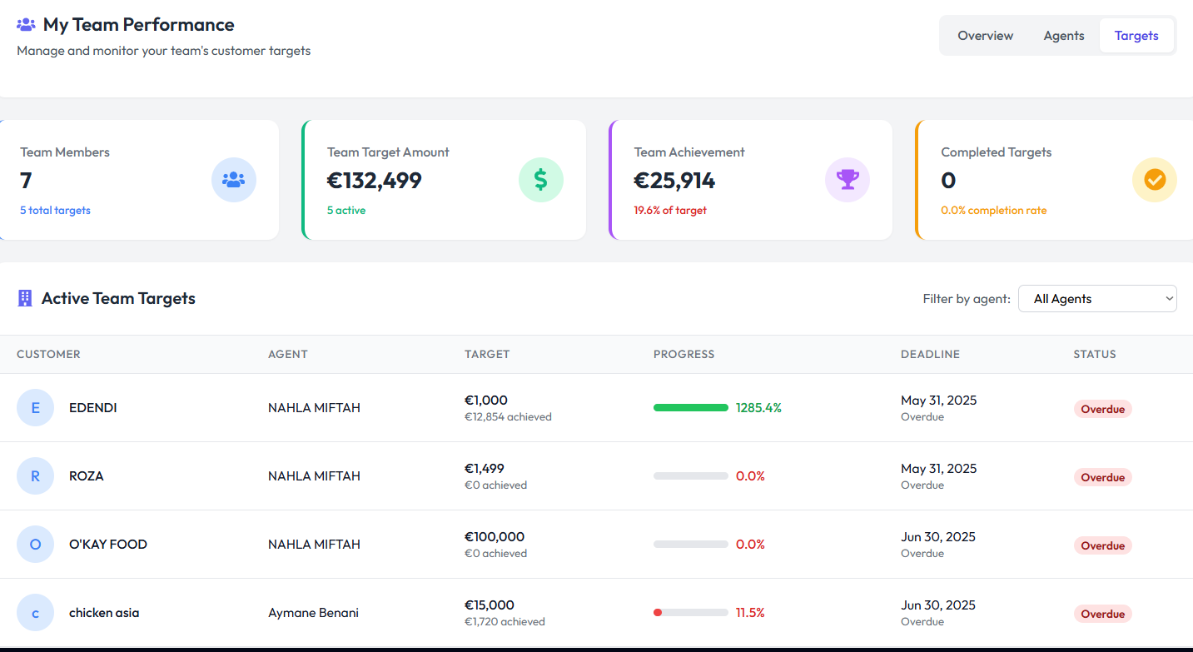

Fig 29. Team performance as per targets

# Abandoned Carts View:

Abandoned carts can be viewed by going to the abandoned cart analysis tab where you can see an overview of the abandoned carts such as:

* Abandoned carts
* Potential lost revenue
* Recovery opportunities
* Conversion rate

You can see the overview in Fig 30.

# 

Fig 30. Overview of abandoned carts

You can view the top products that have been abandoned in the top abandoned products list as shown in Fig 31.

# 

# 

Fig 31. Top abandoned products view

# Managing Quotations:

On this dashboard you can manage all the quotations that have been made. The actions you can perform are:

* View
* Approve
* Reject
* Print
* Email to customer

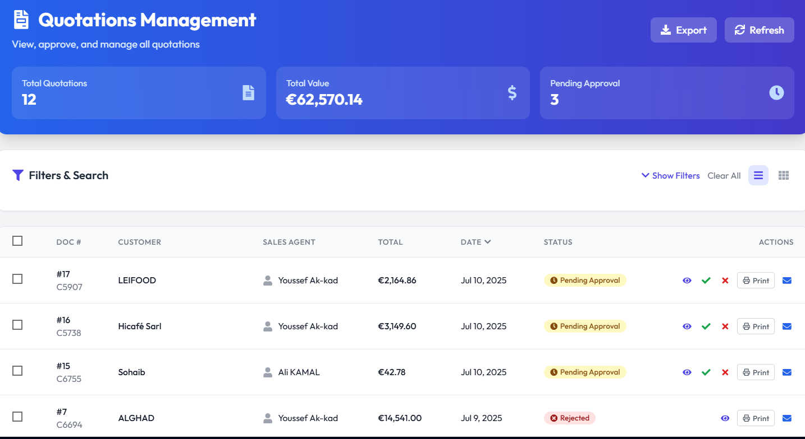

Fig 32. Quotation management dashboard

You can also export all the quotations by clicking on the **export** button on the top right of the screen as shown in fig 32.

# Sales Agents:

Here you can view all the sales agents that are a part of your team. You can also search sales agents.

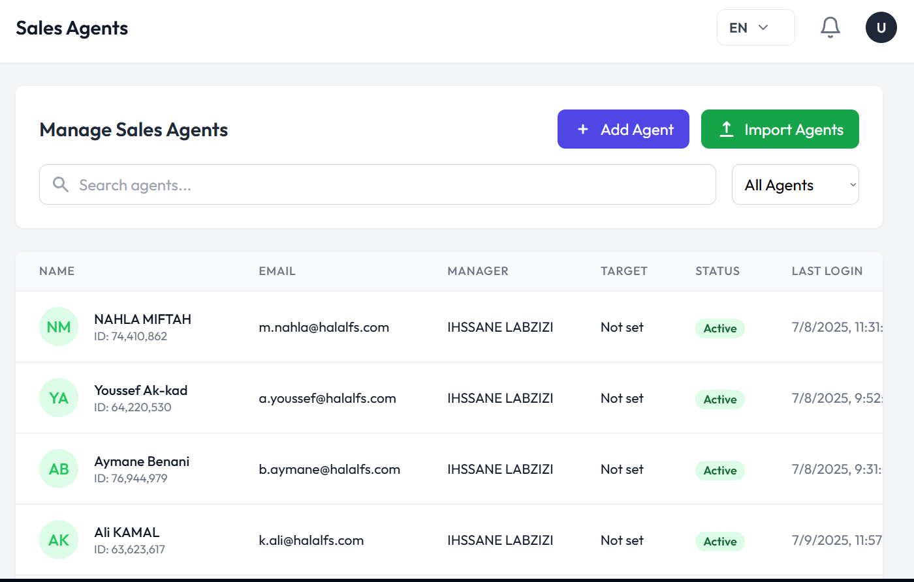

Fig 33. Sales agent overview

## Adding a New Agent:

You can add a new agent to your team by clicking on the **add agent** button as shown in Fig 33.

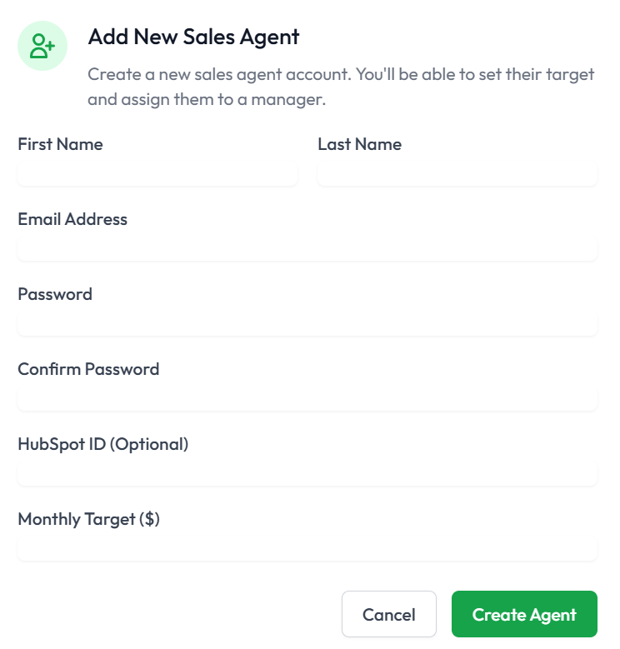

Fig 34. Form to add new sales agent

Then fill out the basic information in the form shown in Fig 34 and press the **create agent**  button.

## Import Sales Agent:

You can also add multiple new sales agents by importing an excel file as shown in Fig 35.

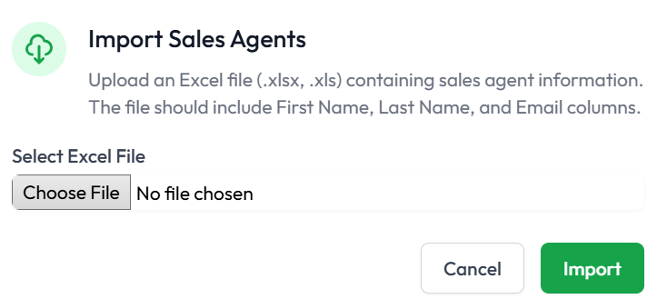

Fig 35. Importing multiple sales agents using excel files

Press the **import**  button and multiple sales agents will be created.

## Actions:

You can perform multiple actions on each sales agent in your team. Some actions include:

* Editing sales agent profile
* View sales agent profile where you can reset profile, view an overview, targets, customers and other details of each sales agent
* Reset password
* Deactivate profile

# 

# Recommendations:

You can view data driven sales recommendations and insights in the recommendations tab. Here you will have a view of:

* Business insights
* Key business facts
* Monthly sales trends
* Sales opportunities

You can refer to Fig 21, 22 and 23 for a better understanding.

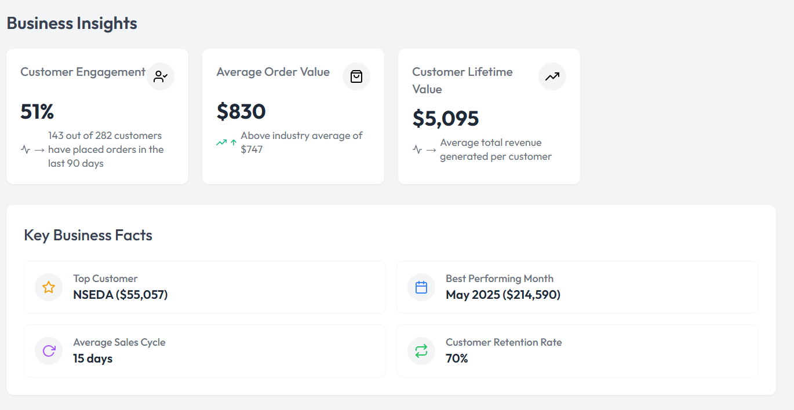

Fig 36. Business insights and Key business factors on recommendations tab

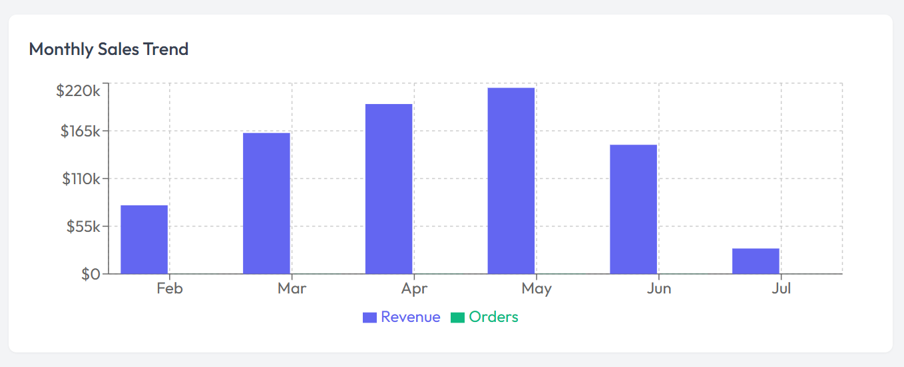

Fig 37. Monthly sales trend on recommendations tab

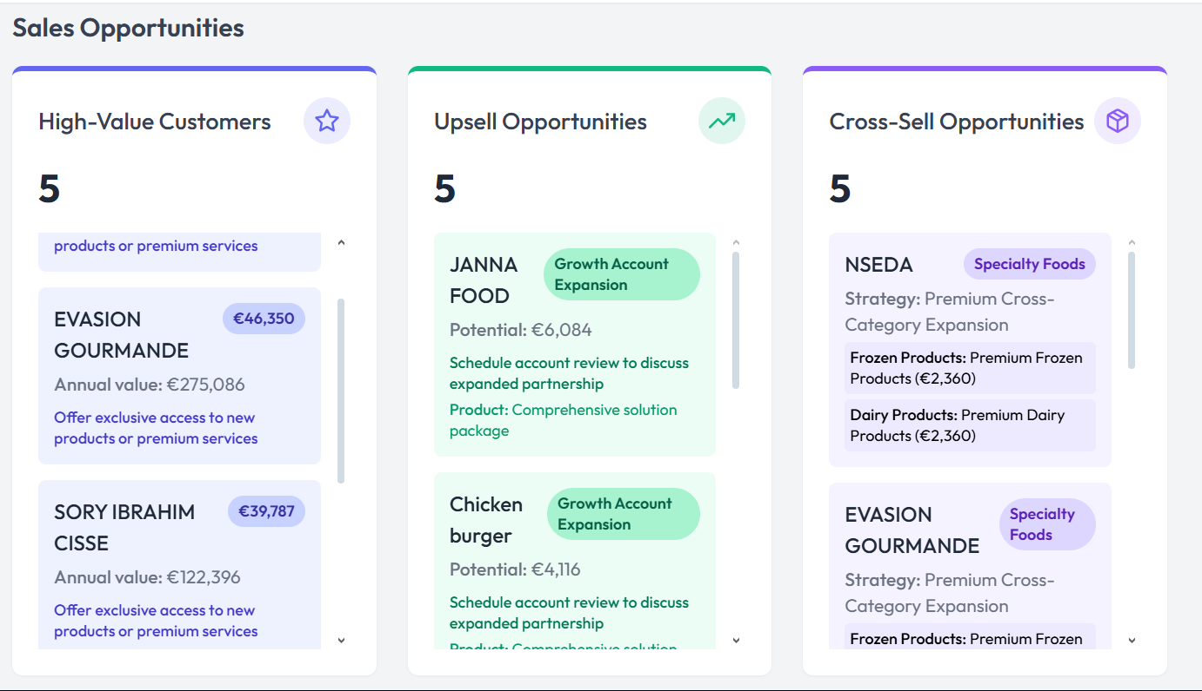

Fig 38. Sales opportunities one recommendations tab